1 | 驚聲銅像廣場 | Statue of Mr. Chang Ching-sheng | 12 | 會文館(F) | Hwei-wen Hall (F) | 22 | 文錙音樂廳 | Carrie Chang Music Hall
2 | 大門管制站 | Main Entrance Guard House | 13 | 商管大樓(B) | Business and Management Building (B) | 23 | 學人宿舍 | Faculty Residences
3 | 紹謨紀念游泳館(N) | Shao-mo Memorial Natatorium Complex (N) | 14 | 海事博物館(M)  黑天鵝展示廳 | Maritime Museum (M)  Black Swan Exhibition Hall | 24 | 覺生紀念圖書館(U) | Chueh-sheng Memorial Library (U)
4 | 騮先紀念科學館(S) | Liu-hsien Memorial Science Hall (S) | 15 | 工學館(G) | Engineering Building (G) | 25 | 覺生綜合大樓(I) | Chueh-sheng Memorial Hall (I)
5 | 鍾靈化學館(C) | Chung-ling Chemistry Hall (C) | 16 | 工學大樓(E) | Main Engineering Building (E) | 25 | 覺生國際會議廳(10樓) | Chueh-sheng International Conference Hall (10th Fl.)
6 | 圖書館鍾靈分館 | Chung-ling Library | 17 | 教育學院(ED) | College of Education (ED) | 26 | 學生活動中心(R) | Student Activity Center (R)
7 | 傳播館(Q) | Communication Hall (Q) | 18 | 松濤館(Z) | Sung-tao Hall (Z) | 27 | 教職員停車場 | Faculty Parking Lot
8 | 傳播館(O) | Communication Hall (O) | 19 | 文錙藝術中心 | Carrie Chang Fine Arts Center | 28 | 視聽教育館(V) | Audio-visual Education Building (V)
9 | 紹謨紀念體育館 (SG) | Shao-mo Memorial Gymnasyum (SG) | 20 | 外國語文大樓(FL) | College of Foreign Languages and Literatures (FL) | 29 | 行政大樓(A) | Administration Building (A)
10 | 麗澤國際學舍(J) | Reitaku International House (J) | 21 | 驚聲紀念大樓(T) | Ching-sheng Memorial Hall (T) | 30 | 宮燈教室(H) | Chinese Palace-style Classrooms (H)
11 | 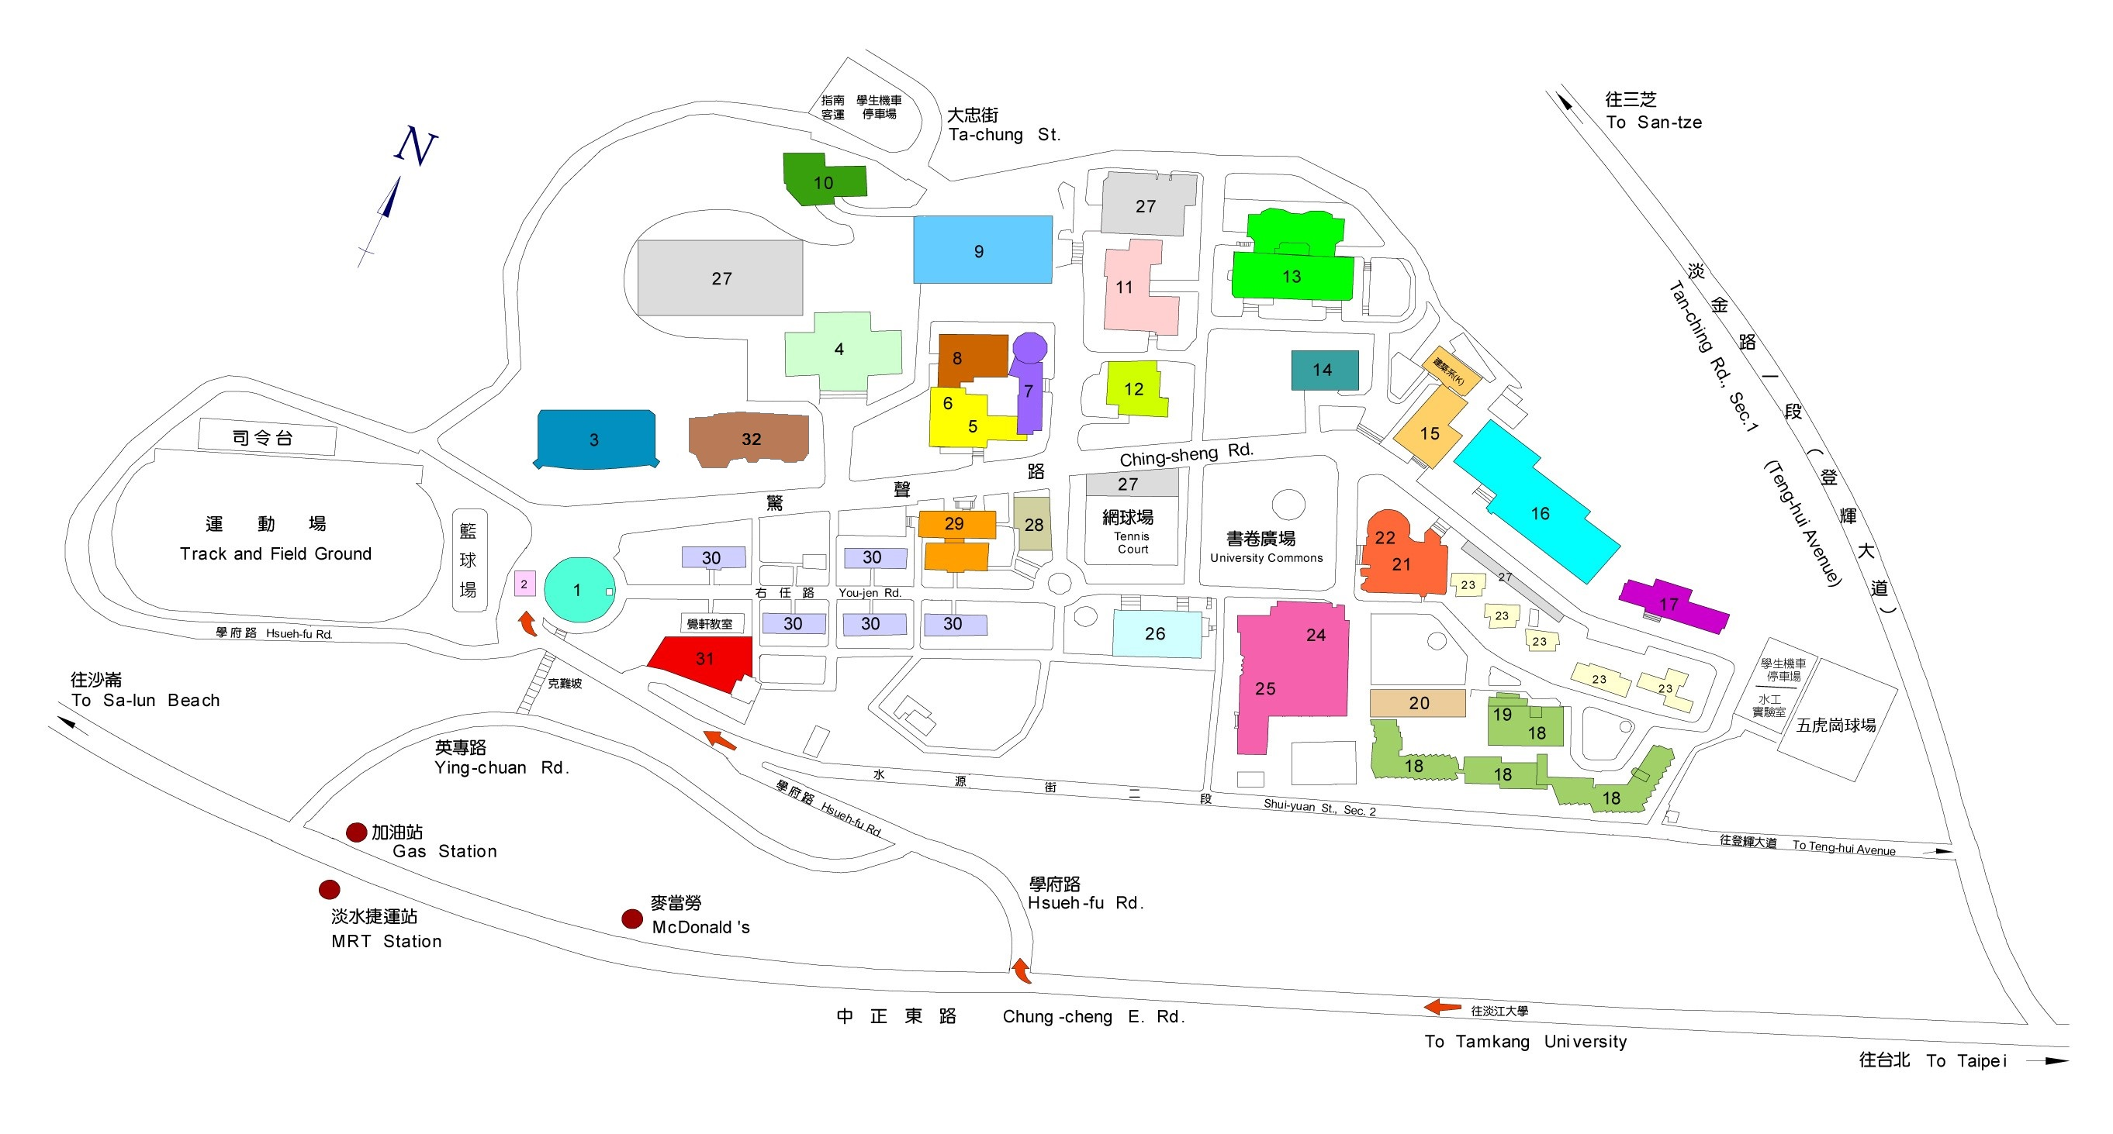  文學館(L) | College of Liberal Arts (L) | 21 | 驚聲國際會議廳(3樓) | Ching-sheng International Conference Hall (3rd Fl.) | 31 | 覺軒花園 | Chueh-hsuan Chinese Garden
 |  |  |  |  |  | 32 | 守謙國際會議中心 | Hsu Shou-Chlien International Conference Center

