Request for Xerox Copying(Application Form)
Department |  | File No.
Please make sure that you indicate the name of the author and the title of the book or article and that you follow the law of copyright in case you have to make copies from others’ works. Anyone who requests xerox-copying should be responsible for his/her own breach of copyright.
Applicant |  | Tel.
Preparer |  | Tel.
Course Title
No. of Original | A4（ ）、B4（ ）
Type of copies  Only Double-sided | □A4→A4 DBL |  | □PPT→A4(4 in 1)DBL
Type of copies  Only Double-sided | □A4→enlarge B4 DBL |  | □PPT→B4(8 in 1)DBL
Type of copies  Only Double-sided | □A4→combine B4 DBL |  | □PPT→A4(6 in 1)DBL
Type of copies  Only Double-sided | □B4→B4 DBL
No. of copies
Date Submitted | ____(M)____(D)____(H) | Date to be picked up |  | ____(M)____(D)____(H)
Special Request | □I need Single-sided only  □another(please describe detail)
Evening Program | Send to College
For Staff only
Handing |  | Print |  | On Shelf

--------------------------- 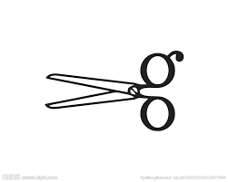-------------------------
Request for Xerox Copying(Applicant’s Copy)
Department |  | File No.
Applicant
Course Title
Date Submitted | ____(M)____(D)____(H) | Date to be picked up | ____(M)____(D)____(H)
ATRX-Q03-001-FM402-06

